Infusing Institute Presentation
- Future Projects
-I have collected a notebook full of notes, valuable readings, and additional resources if I teach our Asian Literature Course and / or if I get to teach a “linked” course with an Asian Art, History, or Religion class (hopefully within the next 5 years).

- Infusion Opportunities for This Semester
Composition I and Developmental Writing Courses
Prewriting assignment for an English 091 (Writing Fundamentals) class
I will have the class watch the first clip (of Uyghur music) after a discussion on capturing sensory details. I would ask them to write down as many descriptive details that they can and possibly any personal response to the clip. We would then put some details on the board from their responses. After writing some details on the first clip, I would have the class watch the second clip and do the same thing. Finally, I would have a class discussion where we discussed some similarities and differences in the very different two clips

http://www.youtube.com/watch?v=nIW4Lw36IcI

http://www.youtube.com/watch?v=EZaGVZgc1X8

This assignment would be a low-stakes prewriting exercise for this course, but hopefully it will give them extra insight into preconceived ideas that many of us have with “unfamiliar” experiences. I can also see expanding this idea with many other examples and using it as a full paper in a higher composition course. The students might have to find their own example or analyze a couple of examples (or do some field research gathering impressions from several groups of people on their impressions of unfamiliar cultural practices).

Prewriting assignment for an English 101 (freshman composition) class
I will have the class watch the scene from Departures when the wife finally sees her husband preparing the body (after discussing the movie a little with the students, so they have context). Then I would ask the students to describe any visitation, wake, or funeral practices that they have personally witnessed either as part of their own culture / family practice or someone else’s. I would have them reflect on things they find comforting in the rituals, things they find unpleasant or uneasy, and any other reactions they can think of about the experience.

I would use this by itself as a reflective journal low stake’s assignment or as a prewriting exercise to be expanded by looking at other examples of different cultural ceremonies as maybe a comparison piece or a definition paper explaining the notion of “ceremony” to an outsider.
Example of a writing assignment for English 101 (freshman composition)

I will have students read the story “Eating Crabs.”
After discussing the readings as a class, I would give the students the option of writing a personal narrative either discussing a time when they didn’t know something and learned a lesson (similar to the young wife in the passage) OR a time when they got angry at someone for something only to realize that they were in the wrong (similar to the young wife in the passage). They would describe what happened and explain what they learned from the experience and / or how it compares to the story they read.
Example of a journal assignment for an English 101 (freshman composition) course

I will have students read the following passage from The Complete Works of Chuang Tzu (translated by Burton Waston):
Words are not just wind. Words have something to say. But if what they have to say is not fixed, then do they really say something? Or do they say nothing? People suppose that words are different from peeps of baby birds, but is there any difference, or isn’t there? What does the Way rely upon, that we have true and false? What do words rely upon, that we have right and wrong? How can the Way go away and not exist and not be acceptable? When the Way relies upon little accomplishments and words rely on vain show, then we have the rights and wrongs of Confucians and Mo-ists. What one calls right the other calls wrong; what one calls wrong the other calls right. But if we want to right their wrongs and wrong their rights, then the best thing to use is clarity.
Everything has its “that,” everything has its “this.” From the point of view of “that” you cannot see it, but through understanding you can know it. So I say, “that” comes out of “this” and “this” depends on “that”—which is to say that “this” and “that” give birth to each other. But where there is birth there must be death; where there is death there must be birth. Where there is acceptability there must be unacceptability; where there is unacceptability there must be acceptability. Where there is recognition of right there must be recognition of wrong; where there is recognition of wrong there is recognition of right. Therefore the sage does not proceed in such a way, but illuminates all in the light of heaven. He too recognizes a “this,” but a “this” which is also “that,” a “that” which is also “this.” His “that” has both a right and a wrong in it. So, in fact, does he still have a “this” and “that”? A state in which “this” and “that” no longer find their opposites is called the hinge of the Way. When the hinge is fitted into the socket, it can respond endlessly. Its right then is a single endless and its wrong too is a single endless. So, I say, the best thing to use is clarity.
I will also read this passage aloud in class along with other works where writing that might at first seem unclear, contradictory, or repetitive, can provide meaning and insights
I can think of at least two journal responses I would like to try with this reading. I would also like to use some of the ideas from this passage to formulate a longer essay for my composition class, but I need to think about other items to pair it with before I would do that.
- You need to find some statements within this reading that you find true and freewrite an interpretation / explanation of what you think that part means. You need to pick at least two and can choose more to meet your required journal length.
- The beginning of this passage says, “Words have something to say.” What do you think about how this passage uses words to “say” something? Do you feel you understand it (some of it, all of it)? What do you notice about the rhythm and parallel structure of the reading? How does that affect you as reader? Finally, if you read it aloud, what did you notice about the sound of this passage? Like other journals, you don’t have to answer all of these questions, but you should reflect on the ones that affected you most.
This assignment would be a low-stakes journal assignment with the potential to become a larger writing assignment.
Children’s Literature
-I use a rotating list of social, family, and
cultural diversity novels, and this institute has
helped me with the background needed to
discuss some of the background information
that comes up with some of the Japanese and
Chinese texts that I use
-I have taken photographs of hundreds of
Japanese and Chinese children’s books and
manga books. I can use these as examples of
general concepts we discuss
Example of fantasy:

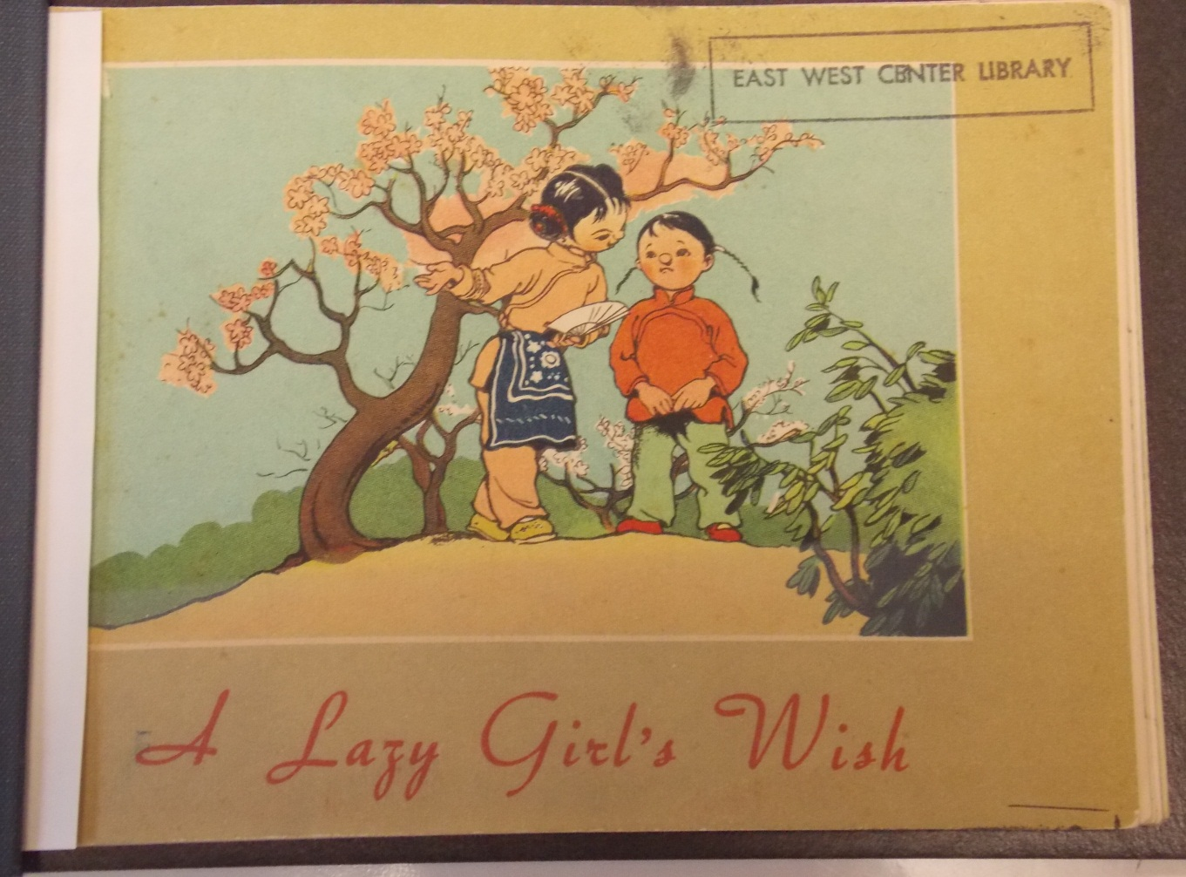

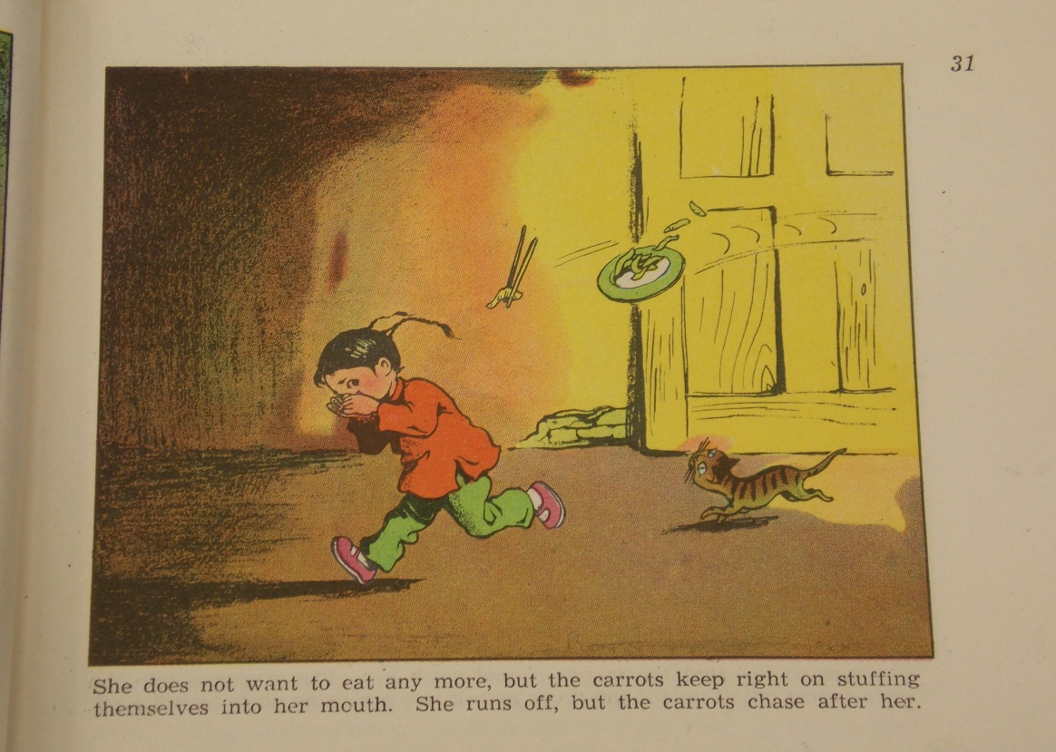
Example of Mother Goose
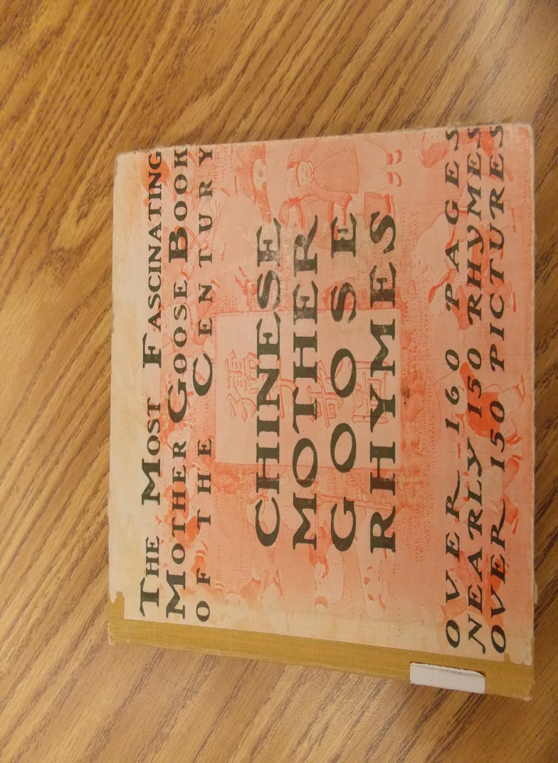

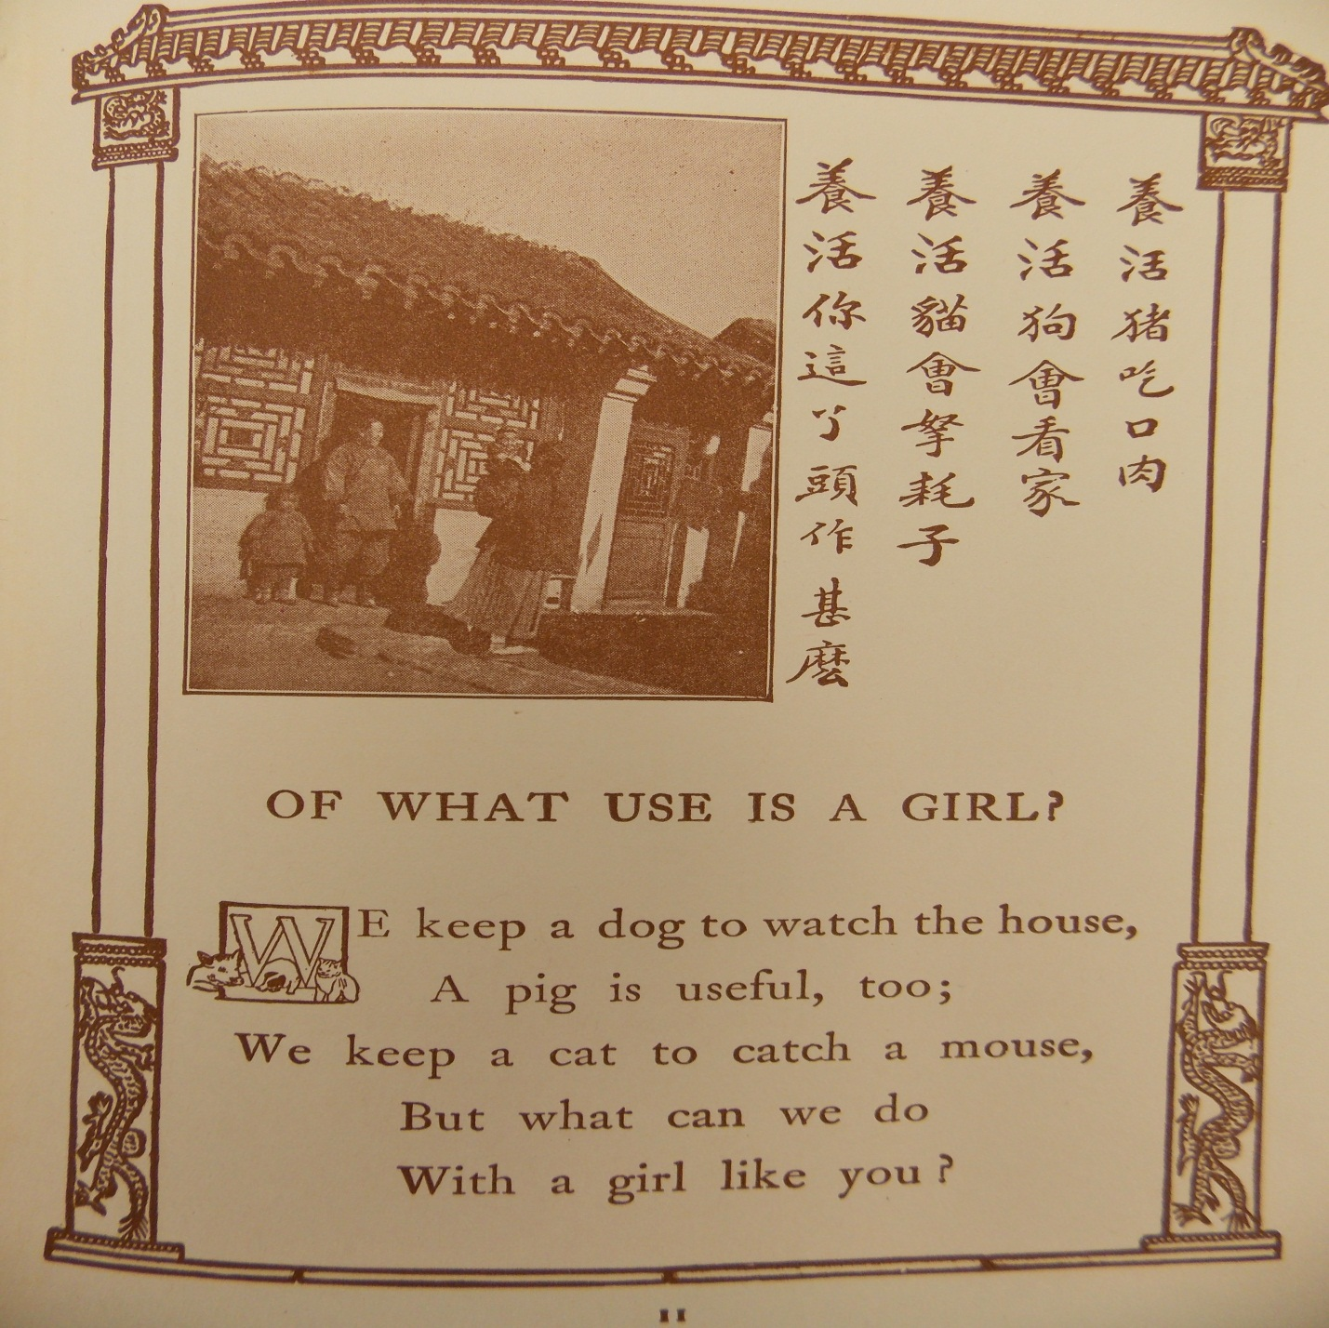

Example of Collage Illustration

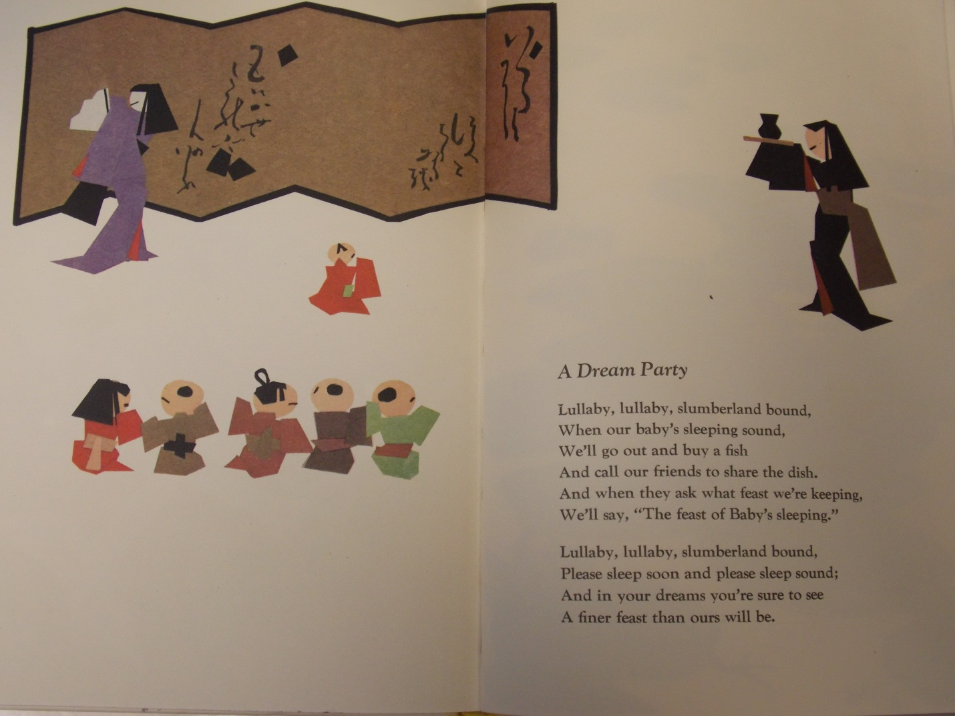

Professor Nicole Banks
English Department
Black Hawk College (Moline, Illinois)

