Community-based forest management within a globalized economy: Examining local and distant drivers of forest cover change in the Middle Hills of Nepal
- Introduction
Deforestation and protracted forest degradation have caused concern among scientists, policy makers, and citizens around the globe (DeFries et al., 2002; FAO & JRC, 2012; Hansen et al., 2008; Hansen, Stehman, & Potapov, 2010), but a number of recent studies have documented forest regrowth, reforestation, or afforestation occurring in the same regions and time periods as deforestation and degradation (Southworth et al., 2012; Van Den Hoek et al., 2014). The focus on forest regrowth/regeneration and reforestation/afforestation, collectively referred to as forest “resurgence,” is a welcome change from the singular focus on deforestation and degradation, especially since forest cover expansion has serious implications for biodiversity, carbon sequestration, reduction of greenhouse gas emissions, and other variables (Grainger, 2008). Understanding the socio-environmental contexts within which reforestation occur is critical for policymakers seeking to address climate change at national and global levels.
Hecht (2010) argues that forest resurgence has been overlooked for a number of reasons. First, inhabited landscapes are ‘noisy’. That is, human-dominated landscapes often seem spatiotemporally stochastic and incoherent both in terms of the social forces driving the change and the manifestation of specific biotic outcomes. Second, there are the semantic issues of what a ‘forest’ is and when degradation or resurgence has occurred. For the most part, research and public concern has been biased towards considering ‘old growth’ or ‘primary’ forests while forests that have been affected by protracted disturbance and management over centuries have been ignored. Moreover, there are competing notions of forest resurgence depending on the means of measuring forest cover change, e.g., optical versus structural indicators of forest cover change. Third, most deforestation occurs on economic frontiers. While these regions often witness extensive clearing, the preoccupation with frontier deforestation has diverted attention from resurgent forests that provide ecosystem services such as livelihood sustainability, carbon sequestration, or biodiversity. Finally, studies of forest cover trends are often based on FAO field inventory data, and recent analyses have shown major inaccuracies in how FAO data panels capture forest cover change (Grainger, 2008; Van Den Hoek et al., 2014).
Large scale forest regrowth, reforestation, and afforestation were described by Mather (1990) as the “forest transition”, a trajectory of change where initial forest loss is followed by recovery as a country undergoes social and economic changes. Rudel et al. (2005) distinguished two forest transition pathways: economic development and forest scarcity. The economic development pathway is associated with industrialization and the movement of people from rural areas and towards non-farming livelihoods. The forest scarcity pathway is associated with reduced availability of forest resources and higher timber prices, which cause landowners to invest in tree planting and forest management. Forest scarcity also induces governments to implement policies that restrict forest exploitation, create protected areas, promote community management practices, and invest in forestry research and reforestation programs. Rudel et al. (2005) suggested that the forest scarcity pathway may be more prominent in densely populated and poorer countries of Asia, whereas the economic development pathway may be more prevalent in the richer and less densely populated countries of the Americas. Hecht (2010), however, argues that none of the prevailing deforestation or forest transition models examine the effect of globalization on forest cover; she suggests that the ‘globalization of labor, discourses, knowledge, capital and new emergent markets provide an optic for better understanding the paradoxes of forest recovery that are not captured by forest transition theory’ (Hecht, 2010).
This proposal is a direct response to the NSF Geography and Spatial Sciences Program focus on scientific research that advances theory and basic understanding of challenges facing society, and promotes the integration of geographers and spatial scientists in interdisciplinary research. We seek to document forest cover disturbance and resurgence in Nepal over a 25-year period in a way that not only produces insights into social and ecological dynamics of forest cover, but also broadly advances theoretical understandings of forest transitions, community-based natural resource management, and globalization of labor. To that end, this proposal brings together these three distinct literatures and places them in conversation with each other. This project will further support the development and use of new scientific methods and tools for geographic research and specifically promote the education and training of geographers and spatial scientists within Nepal.

- Research objectives and science questions
This project proposes a multi-disciplinary research program to quantify changes in forest cover in the Middle Hills of Nepal since 1990 and to identify factors significantly associated with these changes. The overarching hypothesis to be addressed is that there has been forest transition in Nepal over the last 25 years, which has waxed and waned across the landscape in response to various socioeconomic and physiographic drivers. We seek to model forest cover change using socioeconomic and physiographic variables identified in the literature as affecting forest cover and for which data are available from the Central Bureau of Statistics (CBS) and the Survey Department. Specific research questions include:
- How has forest cover changed over the last 25 years?
  - Has the intensity of this change varied over time and over the Middle Hills?
  - Has the rate of forest resurgence varied over time and over the Middle Hills??
- Are changes in forest cover related to socioeconomic conditions?
  - Has forest cover change varied by household demographics (age, gender, number of adult workers)?
  - Has forest cover change varied by household socioeconomic characteristics (on- and off-farm income sources)?
  - Has forest cover change varied by agricultural characteristics (farm size, number and type of livestock, crop type)?
- Have foreign remittances affected the rate or pattern of forest cover change?
- Are changes in forest cover related to physiographic conditions?
- Has forest cover change varied by elevation, aspect, distance from roads, and other variables?
In addressing these questions, this project has three overarching objectives: 1) Build a comprehensive database of Middle Hills forest cover change since 1990 (97% of community forest user groups were formed after 2003); 2) Identify socioeconomic and physiographic variables associated with forest cover change and quantify their respective influences; and 3) Assess how foreign labor migration and remittances correlate to forest cover change across the Middle Hills and at a sample of community forest sites. Objectives are realized at two nested scales: the Middle Hills, and Village Development Committees (VDCs), the smallest administrative unit at which government data are compiled.
At the Middle Hills scale, specific research objectives include:
- Build a comprehensive database of forest cover change in the Middle Hills since 1990, and produce maps of forest cover history (disturbance and recovery) at district and VDC scales.
- Develop a forest resurgence scale and classify districts and VDCs according to the amount of forest recovery they have exhibited since 1990.
- Quantify the respective influences of socioeconomic, demographic, and physiographic variables significantly related to forest cover change at district and VDC scales.
- Quantify the spatial correlations between economic migration and remittances with spatially-explicit forest cover change at district and VDC scales.
At the VDC scale, we have one specific research objective:
Develop a qualitative understanding of how institutional (forest management practices), and sociopolitical (out-migration, remittance income) variables affect forest cover from household, key informant, and focus group interviews conducted in 10 VDCs purposely selected as representative of different degrees of forest resurgence.

- Intellectual merit
3.1 Forest transition theory
A thorough discussion of forest transition theory is beyond the scope of this proposal, but a number of issues merit attention. First, forest transition theory generally overlooks differences in types of forest cover with respect to vegetation succession and forest resource use, focusing instead on the dynamics of forest cover (Perz & Skole, 2003). This is an important oversight because the ecological characteristics (e.g., diversity, structure, biomass, etc.) and economic uses (e.g., construction timber, fuelwood, agroforestry, plantation, etc.) of different types of secondary forests may differ substantially (Anderson, 1990; Houghton & Hackler, 2000; Johnson et al., 2001; Nair, 1993; Redford & Padoch, 1992; Tucker et al., 1998). In recognition of the variability in secondary forest resurgence, this project will measure the intensity of disturbance, subsequent recovery, and extent and pattern of forest cover gain and loss, each of which will be used as a dependent variable in a statistical model of forest cover change.
Second, theoretical articulations of forest transitions are vague about crucial details of the transition itself. For example, by focusing on long-run dynamics and assuming a smooth transition over time, little attention is afforded to short-term dynamics that may include reversals in dominance between forest cover losses and gain (Perz & Skole, 2003). In Nepal’s 30 years of experience with community forestry, some patches of forest loss recovered, were deforested again, and then reforested again (Fox, 1984, 1993, in prep). This tempo of forest cover change is common in South Asia, where post-harvest forest resurgence may initially offset and ultimately exceed the rate of deforestation. A “pulsating” recovery – one that waxes and wanes between gain and loss as regenerated forests are logged again– is diagnostic of economically-driven forest transition but has been understudied (Rudel et al., 2005). We will measure extent, rate, and spatial pattern of annual forest cover gain and loss throughout the 25-year period.
Third, despite the fact that most emigrants from developing countries originate in rural communities, there has been little research that assesses the relationship between 1) increased labor mobility and the attendant rise in rural incomes, and 2) changes in forest cover and land use within origin communities. Tiwari and Bhattarai (2011) argue that this is partly because most of the related research has focused on private, household-level outcomes and ignored important community-level interactions such as community forestry. An exodus of working age men from economically isolated villages to cities or foreign labor markets may have implications for the prevailing agricultural wage in the local economies they leave behind. Similarly, remittances may well be private, household-level transfers, but if their size and coverage (in terms of the number of households receiving them) are large, they could alter the forest landscape of a village through several processes, e.g., marginal agricultural lands are abandoned (Leblond, 2010), farmers plant more trees on their private lands (Fox, 1993), and/or farmers can afford to cook with electric, liquefied petroleum gas, kerosene, or other non-firewood sources of fuel reducing pressure on forest resources (Fox, in prep). We will examine the relationship between foreign remittances and forest cover change summarized at district and VDC scales.
Finally, while there are a number of analyses comparing forest transitions in Western developed countries (e.g., Koop & Tole, 1999; Mather, 2001, 2007; Mather & Needle, 1998; Rudel, 1998) as well as in tropical regions, these studies’ shortcomings hinder an assessment of forest transition theory. First, existing empirical work generally relies on Food and Agriculture Organization (FAO) data, which are based on forest inventories of varying quality and methods, particularly for earlier time periods (e.g., Downton, 1995); it is now widely recognized that remote sensing methods are superior for spatiotemporally consistent surveys of forest cover (e.g., Downton, 1995; Fox et al., 2003; Meyer & Turner, 1994). Second, previous work is idiosyncratic and methodologically diverse, with some analyses emphasizing historical particularities and others highlighting significant statistical patterns in cross-national models; most research has been of the latter sort, but remains preliminary due to limitations in data availability and model development (Koop & Tole, 1999; Rudel, 1998). Perz & Skole (2003) argue that one key advance that has helped surmount these studies’ limitations has been to focus on specific countries or regions since subnational units allow for more refined observations and offer more explanatory variables for improved model specification (Rudel, Perez-Lugo et al., 2000). With this in mind, this project will utilize national census data compiled at district and VDC scales to identify socioeconomic variables associated with forest cover change in the Middle Hills of Nepal.
3.2 Community-based natural resource management (CBNRM)
CBNRM encompasses a diverse set of approaches and practices concerned with devolving power and authority to manage natural resources from central governments (e.g., forest departments) to local communities (Ostrom, 1990). Over the past several decades, scholarship on resource use and management has emphasized the key roles of institutions, communities, and socio-economic factors on effecting successful management plans (e.g. Agrawal, 2001; Angelsen & Kaimowitz 1999; Ostrom, 1990; Southward & Tucker, 2001), emphasizing the importance of a variety of causal variables and processes. Yet knowledge about the magnitude, relative contribution, and even the direction of influence of different causal processes on forest resource management remains poor at best. Agrawal and Chhatre (2006) showed that biophysical, demographic, economic, institutional, and socio-political variables were critical for explaining variation in forest condition. The importance of this finding lies in the fact that the resource governance-related outcomes need to be contextualized within ecological as well as socio-cultural variables. Although institutional theories recognize the importance of these contextual factors (Ostrom, 2009), it is a rare study that explicitly incorporates variables representing all these classes of influences into the analysis (Agrawal & Chhatre, 2006). We build on the work of Agrawal and Chhatre by using many of the same independent variables; our analysis differs in that we will use census data from all the districts and VDCs in the Middle Hills, we will include foreign remittances as an independent variable, and we will map forest cover change using remotely sensed data.
3.3 Globalization
Globalization has increased the worldwide interconnectedness of places and people through markets, information and capital flows, human migration, and social and political institutions. As a consequence, changes in forest cover are shaped by local and global forces in ways that require a reexamination of theory. Recently, the concept of land teleconnections has gained momentum, reflecting efforts to better understand cause-and-effect linkages between distant and apparently unconnected places, and socioeconomic and land use dynamics. Seto et al. (2012) argue that three key themes in land change science can lead to incorrect conclusions if they are not examined jointly: 1) the traditional system of land categorization is based on discrete classes, which reinforces the false idea of a rural/urban dichotomy (we suggest this is also true for the forest/non-forest dichotomy); 2) the spatial treatment of land change that is founded on place-based relationships and ignores distant connection between places; and 3) the implicit assumption that land transitions are path-dependent and sequential—not pulsating as we find in South Asia. This project will document connections between distant drivers and local land uses, and look for evidence of non-path-dependent and non-sequential changes. Lambin and Meyfroidt (2011) identified remittance effects as one of the principal mechanisms through which distal connections can affect forest cover change. Hecht and Saatchi (2007) analyzed satellite imagery to test the relative impact of population and foreign remittances on forest cover in El Salvador between 1992 and 2001. They found for every percentage point increase in remittances, there was a 0.25 increase in the percentage of land with 30% or more tree cover.
In one of the few studies examining the relationship between labor scarcity and land cover change in Nepal, Tiwari and Bhattarai (2011) used remote sensing data on forest cover change together with data from the Nepal Living Standards Survey (NLSS) for 122 village clusters in the Middle Hills. They found that rural economic growth caused by a large influx of remittances into rural Nepal may have had a positive effect on forest cover gain. Given the geographical and economic isolation of the typical Nepali village and the attendant need to rely solely on local forests for all consumption of forest products, Tiwari and Bhattarai’s results are consistent with those of Foster and Rosenzweig (2003), who found a broadly positive causal relationship between village-scale economic growth and forest resurgence in Indian villages. We seek to explore whether such a relationship exists in the Middle Hills of Nepal.

- Background
147,181 km², Nepal is preponderantly a mountainous country composed of three distinct physiographic zones, the Mountains, Middle Hills, and Terai (lowland plains). This project will focus on the Middle Hills; lying between 700 and 4,000 masl, the Middle Hills include approximately 40% of the country’s total land area, 45% of its population, 68% of its forest cover, and 75% of its community forests (DoF, 2012). Stainton (1972) classifies the natural forests in the Middle Hills as belonging to several types. Between 700 and 1,000 masl hill sal (Shorea robusta) grows on the outer foothills and penetrates up the main river valley. Sal is the main forest type of the Terai and is the most highly valued timber in the region. Schima-Castanopsis forests consisting of three Castanopsis species, Castanopsis tribuloides in the West, Castanopsis indica in the east and central Middle Hills, and Castanopsis hystrix in the east are the main forest types between 1,000 and 2,000 masl. Schima walichhi is common in the east and central Middle Hills. Throughout the Middle Hills Pinus forests are also found on north-facing slopes. Stainton notes these forests contain Pinus roxburghii, Quercus incana, Quercus lanuginose, Rhododendron and Lyonia ovalifolia. Because this elevation is heavily populated, with numerous villages and terraced hillsides, all that remains are small forest fragments across the landscape. These forests are used primarily for subsistence purposes—firewood, fodder, grazing livestock, and the logging of small amounts of lumber for house construction (Fox 1983, 1994). Figure 1 shows the 39 districts that define the Middle Hills (Sharma, 2013); these 39 districts are composed of 1,991 VDCs. By examining regional forest cover change since 1990 alongside data on social and economic transformations from the 2001 and 2011 national population censuses and the 2011/2012 agricultural census (Khadka, 2003), it will be possible to assess forest transition hypotheses in the Middle Hills.
4.1 Community-based forest management in the Middle Hills of Nepal
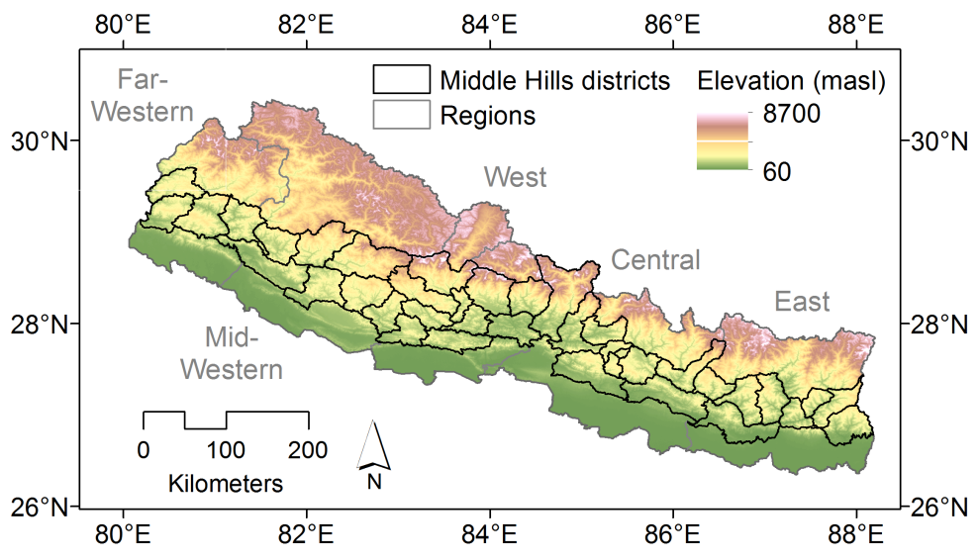
Since the 1980s, Nepal, one of the poorest countries in the world (Malik, 2013), has gained worldwide recognition for path breaking achievements in community forest management. Community forests are a critical component of Nepal’s forests that cover upwards of 40% of Nepal’s national area (nearly 5.5 million ha) and are one of the country’s major productive resources, contributing about 10% to the gross domestic product (GDP) (MSFP, 2013). In 1988, Nepal’s Department of Forests (DoF) identified 61% of the nation’s total forest area (3.5 million ha) as forest that could be transferred legally to local communities and managed for their benefit (Acharya, 2002). Today, community forests occupy nearly 23% of Nepal’s total forest area (1.2 million ha), the management of which involves over 18,000 community forest user groups comprising 1.6 million households and nearly 40% of Nepal’s population (DoF, 2012).
Figure 1. The mountainous terrain of Nepal’s Middle Hills; the 39 districts we will study are outlined in black.
According to the DoF database (2012) there are a total of 18,000 community forest user groups (CFUGs) of which 16% are in the Mountains, 75% in the Middle Hills, and 9% in the Terai. As of 2011, there were over 1.65 million ha of community forest in the Middle Hills (DoF 2012). The mean area of a Middle Hills community forest was approximately 94 ha, but forest extent varied from less than 10 ha (28% of community forests) to more than 100 ha (31%), and a recent survey found that community forests in the Middle Hills tend to be small and heterogeneous. The spatially-explicit impacts of this transition in forest management have not been documented in part due to the difficulty of mapping forest cover in mountainous environments where remote sensing imagery analysis is hindered by topographic effects, e.g., shading, the presence of clouds, snow, and ice, and the inaccessibility of areas of rugged terrain for ground truth data collection. Indeed, only three national scale forest surveys have been conducted in Nepal: two using aerial photography, 1963/64 and 1978/79, and one using Landsat imagery from the early 1990s (Acharya et al., 2012). Mapping Nepal’s forest transition and developing a comprehensive understanding of factors underlying observed changes in forest cover are critical if Nepal is to improve upon its already successful resource initiative.
Nepal also earns a greater share of its wealth from emigrant workers than any other country in the world. Migration dominates most households’ livelihoods choices as almost half of all households in Nepal have at least one migrant abroad or a returnee (Stevens et al., 2011; Tiwari & Bhattarai, 2011). Remittances are the main source of foreign currency and migration remains the main livelihood choice of young people between the ages of 20 and 44 (Ghimire et al., 2011). Current figures indicate there are about four million migrants – one-third of the working male population – and foreign remittances constitute a quarter of the income of all households (Adhikari & Hobley, 2011). In 2009, 22% of the GDP was drawn from remittances, a figure that does not include remittances from India and undocumented or informal sources (Ghimire et al., 2011). Given the prominent role of remittance income, an exodus of working age men and the input of foreign wages could truly alter the economic landscape of a given village (Tiwari & Bhattarai, 2011).
Longitudinal field work by P.I. Fox in a village in Central Nepal between 1980 and 2010, in which community forest management was introduced and foreign migration grew in importance, exemplifies the types of changes occurring in the Middle Hills (Fox in prep.). During this 30 year period the population of the village grew from 701 to 844 people or an annual rate of 0.62% (against a national rate of 1.93%), suggesting a high rate of outmigration. While in 1980 the number of out-migrants were so few that they were not recorded, by 2010, 90 people (29% of adult male population) were reported as having migrated for work (a large number of seasonal migrants may not have been reported). By 2011, illiteracy had been reduced from 59% to 16% of village population; farmers kept significantly fewer cattle; and villagers consumed significantly less firewood, as they diversified their source of fuel to include liquefied petroleum gas, biogas, coal, kerosene, and electricity. The sal forest (Shorea robusta) and the community-managed religious forest were in much better condition in 2011 than they had been in 1980 but the small communal forests, which had shown improvement between 1980 and 1990, were again degraded by 2010. Observed changes on the ground were corroborated by a Landsat-based analysis: the normalized difference vegetation index (NDVI) of Landsat images showed significantly improved condition between 1989 and 1999 followed by a decline between 1999 and 2009.
4.2 Remotely sensed forest cover change in the mountainous Middle Hills
Satellite imagery analysis mapping changes in Nepal’s forest cover and developing a comprehensive understanding the spatially-explicit processes underlying these changes is critical if Nepal is to improve upon its already successful resource initiative. Thirty-meter resolution satellite imagery collected by NASA/USGS’s Landsat program offers an incomparable perspective on forest cover change across Nepal. The earliest Landsat imagery of Nepal’s forests date to 1972, and have been collected more or less routinely every 16 days with enough spectral and spatial detail to discriminate forest types, forest cover disturbance and resurgence, as well as overall condition. However, there is considerable difficulty in mapping forest cover in mountainous environments like Nepal’s where imagery analysis is hindered by topographic effects, e.g., shading, the presence of clouds, snow, and ice, and the inaccessibility of areas of rugged terrain for ground truth data collection. Indeed, only three national scale forest surveys have been conducted in Nepal: two using aerial photography, 1963/64 and 1978/79, and one using Landsat imagery from the early 1990s (Acharya et al., 2012). An early Landsat-based assessment by Millette et al. (1995) of three village areas in the Middle Hills readily identified most land covers with the exception of forest. This disparity was largely due to differing solar illumination between slopes: greater solar exposure on south-facing slopes made them more favorable for cultivation, while north-facing slopes were left forested but also more shaded, which impeded classification.
Recent advances in imagery pre-processing, algorithmic development, and the expanded availability of complementary geospatial data have been instrumental in supporting highly accurate forest change mapping in mountainous environments (e.g., Brandt et al., 2012; Van Den Hoek et al., 2014). Specifically, the development of global digital elevation models (DEMs) such as the ASTER GDEM2 (Hayakawa et al., 2008) and Shuttle Radar Topography Mission (SRTM) DEM (Slater et al., 2006) with spatial resolutions of 30 m and 90 m, respectively, terrain illumination correction approaches (e.g., Tan et al., 2013), and radiometric correction techniques (e.g., Canty et al., 2004; Masek et al., 2006; Vicente-Serrano et al., 2008) have become central in mitigating variable solar illumination and terrain conditions to produce satellite imagery data that are both geometrically and spectrally faithful to on-the-ground conditions.
Nepal’s persistent cloud cover and missing data resulting from the Scan-Line Corrector (SLC) error in Landsat-7 imagery acquired after February 2003 present further obstacles to accurate mapping of forest cover change. Cloud-masking and multi-date, intra-annual imagery compositing techniques (e.g., Roy et al. 2010) may be used to leverage available data, but imagery with excessive (> 50%) cloud cover is often of little value and may result in intermittent temporal coverage. Breaks in Landsat coverage can be addressed in multiple ways: through fusion with cross-scale imagery, e.g., MODIS or very high resolution (VHR; 1–2 m) multispectral unclassified commercial imagery; adoption of a forest regrowth or disturbance detection algorithm that is robust to intermittent imagery gaps, such as the Vegetation Change Tracker (VCT; Huang et al., 2010) or LandTrendr (Kennedy et al., 2010); or interpolating across missing imagery dates by using a time-series signal processing algorithm such as a Kalman filter or Bayesian minimum mean square error (MMSE) estimator.
Finally, the relative inaccessibility of forests in the Middle Hills impedes the collection of ground truth data necessary for calibrating and validating satellite imagery-based estimates of forest regrowth or disturbance. A ground truth sampling approach must accommodate the diversity of forest conditions in the Middle Hills, but such a sampling regime is exceptionally time-intensive. To circumvent this, VHR multispectral imagery (e.g., GeoEye-1, IKONOS, Quickbird, and WorldView-2) that provide a spatially detailed perspective on forest cover over a broad spatial extent may be used. For example, a pseudo-annual mosaic of VHR imagery spanning the Middle Hills would allow for the collection of validation data to assess the accuracy of Landsat-derived forest cover change. VHR imagery thus offer spatially extensive validation data suitable for capturing the spatially diffuse and small-scale forest changes common to the Middle Hills (Fox, in prep.).
4.3 National censuses and socioeconomic data
Research has shown the benefits of merging national census (mainly population and agricultural) and socioeconomic (household, district, and regional) survey data with remote sensing data to examine the nexus of land-cover and land-use change and demographic and socioeconomic processes (e.g., Cai & Sharma, 2010; De Espindola et al., 2012; Frolking et al., 2002; Heinimann et al., 2013; Karimi et al., 2011; Perz & Skole, 2003; Saksena et al., 2014). For example, Perz and Skole (2003) integrated inter-annual satellite imagery- and census-based information for municipalities in the Brazilian Amazon: imagery captured forest cover change, whereas census data provided indicators of social processes driving the observed forest transition. In Laos, Heinimann et al. (2013) used village-scale Population and Housing Census data to characterize the pattern of shifting cultivation relative to key socioeconomic parameters. In Vietnam, Saksena et al. (2014) established an urban classification scheme by using national census and remote sensing data to identify and map the smallest administrative units for which data are collected as rural, peri-urban, urban, or urban core. The urban transition, almost always involves wrenching social adjustment as small agricultural communities are forced to adjust rapidly to industrial ways of life.
In Nepal, the Central Bureau of Statistics (CBS) collects data through decadal census surveys on demographic, social, economic, and natural resource variables. These data are compiled and distributed at district, municipality, and VDC levels (Sharma et al. 2013) and provide the means to interpret forest dynamics in the Middle Hills with local and regional socioeconomic drivers. For example, Adikhari et al. (2004) found that income was positively associated with fuelwood collection – wealthier households collect more fuelwood than poorer households – and education was negatively associated with fuelwood consumption since higher levels of education provide a wider range of employment opportunities and reduce forest dependency. Gunatilake (1998) also found that family education level is negatively related to forest dependency. Households with large numbers of livestock spent more time collecting grass and fodder from community forests. Data on income, education, and number of livestock are available in the national demographic and agricultural censuses at district and VDC scales.
- Technical Approach
Objective 1: Build a comprehensive database of forest cover change in the Middle Hills over the last 25 years.
Developing accurate maps of forest cover change is the first step in understanding the influence of Nepal’s community forestry program on regional forest dynamics. An annual time-series of Landsat imagery from 1990 to the present will act as the backbone of the forest cover change analysis. Imagery with less than 20% cloud cover will be collected on similar pre-monsoon (January-March) acquisition dates each year to minimize potential differences in solar illumination, shadow angles and length, phenology, and temperature and precipitation conditions while simultaneously supporting discrimination between forest cover and fallow agriculture (Nagendra et al., 2005). Together, these images offer spectral and spatial consistency across the Middle Hills, season after season, for the last 25 years. Thus, while the socioeconomic processes influencing the observed patterns of forest cover change may vary over time and space, the characterization of forest cover and changes therein will be stable.
To accurately map forest cover change in Nepal’s mountainous Middle Hills, a high quality DEM is needed that represents fine-scale terrain features and captures the potential for differing solar illumination. We will use the 30 m spatial resolution ASTER Global Digital Elevation Model Version 2 (GDEM2) generated from imagery collected by the Advanced Spaceborne Thermal Emission and Reflection Radiometer (ASTER) sensor aboard NASA’s Terra satellite for topographic normalization. GDEM2 is a photogrametrically-derived DEM with elevations based on ASTER’s visible and near-infrared (VNIR) band, which simultaneously acquires imagery from different look angles, thereby offering a stereographic perspective of the landscape. GDEM2 elevations reflect the combined influence of topographic elevation and the height of terrain features such as trees, yet GDEM2’s absolute vertical accuracy was measured to within 0.20 m across land cover types in the continental United States (Tachikawa et al., 2011). Though GDEM2 has been shown to generally underestimate elevation relative to the SRTM DEM (Suwandana et al., 2012) and has a higher vertical RMSE in mountainous regions, GDEM2’s vertical bias is less pronounced on complex, sloping terrain and it more accurately projects terrain features – an attribute critical for effective topographic normalization – than the SRTM DEM (Amans et al., 2013).
A critical component of mapping forest cover change is the accurate and spatially consistent measurement of spectral reflectance over forest and other land covers (Townshend et al., 2012). The varying illumination conditions resulting from complex topography make this difficult, however, and must be minimized prior to measuring forest change. We will apply the illumination correction model developed by Tan et al. (2013), which reduces the correlation between terrain-driven conditions of illumination and measured Landsat reflectance at the pixel level and significantly improved the classification accuracy of the resulting forest cover change map. Landsat imagery are first corrected to at-surface reflectance using the LEDAPS algorithm (Masek et al., 2006), and the ASTER GDEM2 in combination with solar illumination information are used to build a shadow mask and derive the illumination conditions. Four products – Landsat reflectance data, a simple dense/sparse vegetation cover map based on the normalized difference vegetation index (NDVI) threshold of 0.50, the shadow mask, and illumination conditions – are input to an empirical rotation model (Tan et al., 2010). This model describes the relationship between illumination conditions and observed pixel-level reflectance, and outputs a corrected reflectance for each pixel in each Landsat image band. With terrain-corrected Landsat imagery in hand, intra-annual image compositing to account for SLC-error gaps and ice and cloud pixels will be carried out.
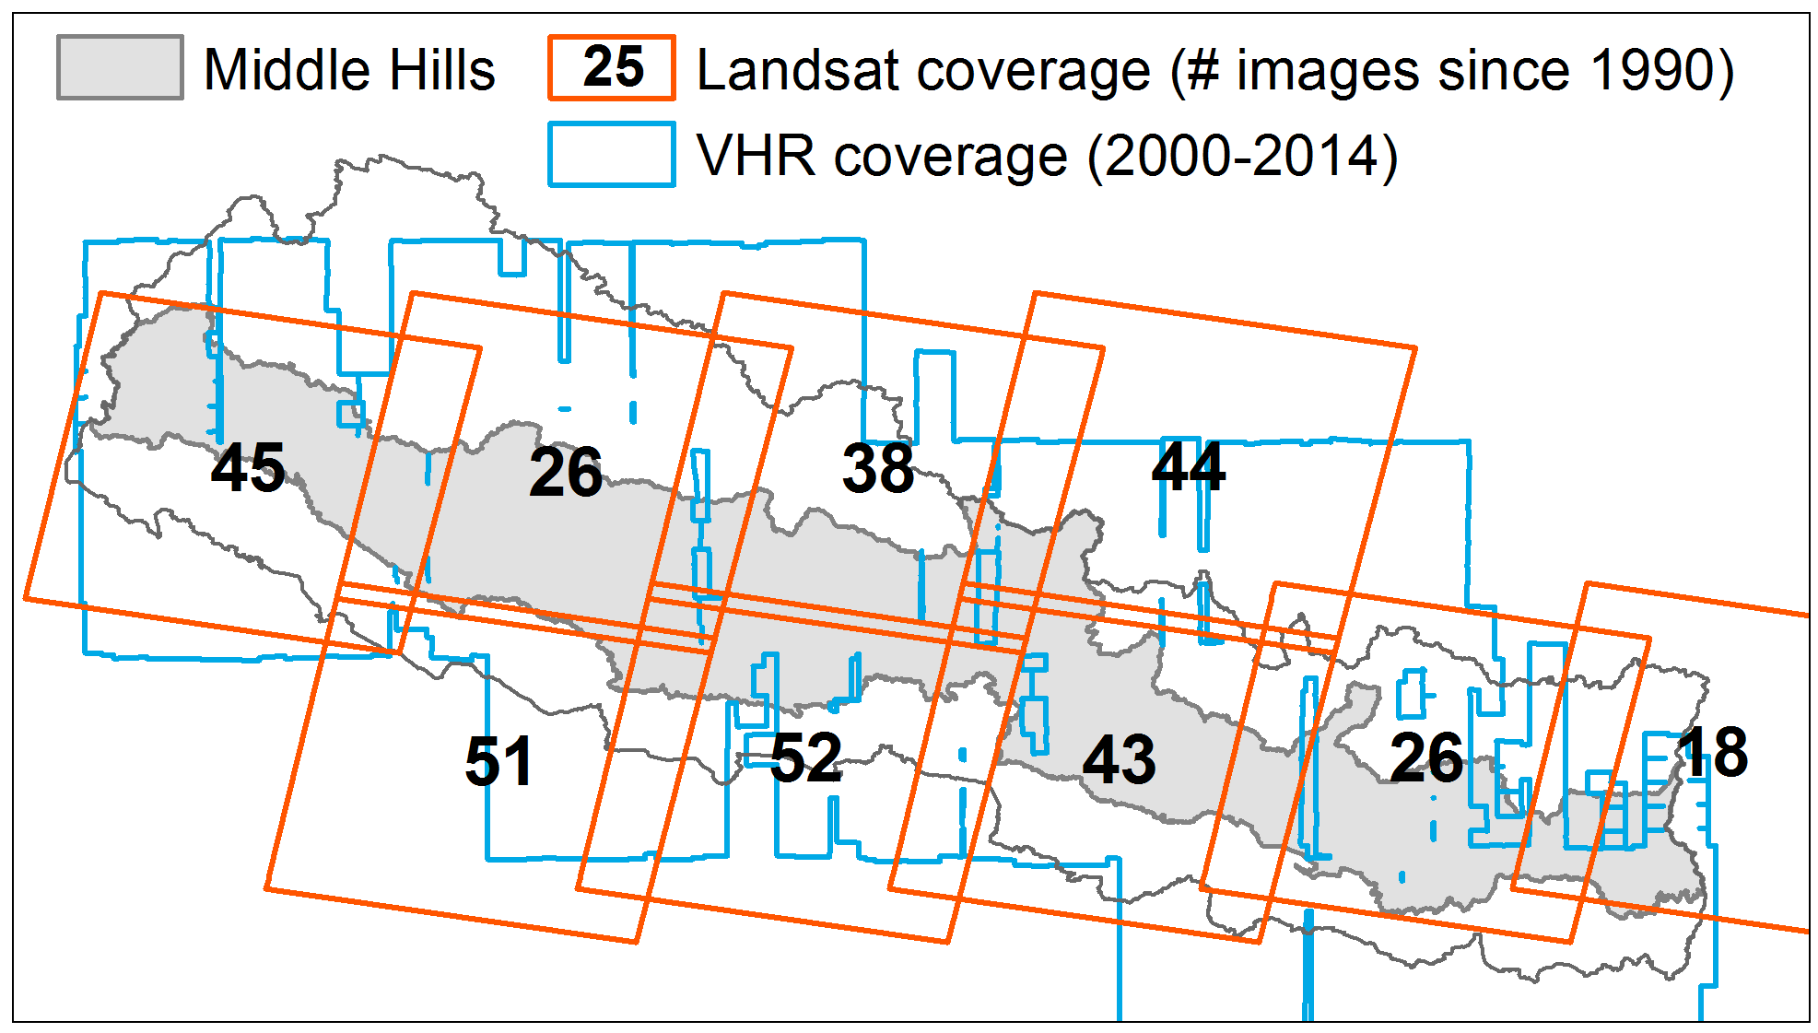
The resulting annual Landsat composites form the basis of the forest cover change detection approach and will be input to the Vegetation Change Tracker (VCT) (Huang et al., 2010) forest cover disturbance mapping algorithm. VCT robustly captures annual disturbances, long-term disturbance trends, as well as forest regeneration, and this project will be one of the first to carry out an automated forest disturbance analysis in a mountainous landscape (Powell et al., 2012; Stueve et al., 2011). Forest disturbance maps will depict the date and intensity (i.e., the degree of forest stand clearing) of disturbance events, as well as the subsequent recovery (i.e., rate of increase in forest cover). Only disturbance events above a calculated intensity threshold will be considered, allowing discrimination between clear-cut and partial harvest events. VCT will also be used to quantify the annual increase in forest cover through natural regeneration and reforestation/afforestation. Forest cover gain and loss patches will be delineated and their composition, distribution, and location relative to landscape features (e.g., villages, roadways, etc.) will be quantified using landscape ecology pattern metrics. Landsat-derived results will be summarized at VDC-, district-, and watershed-levels, and contextualized by coarser resolution MODIS- and AVHRR-derived forest cover maps as well as VHR satellite imagery (Fig. 2). We will develop a forest resurgence scale based on the percentage change in forest cover since 1990, and classify districts and VDCs according to the amount of forest recovery they exhibit. The degree of forest resurgence will inform our sampling framework for more intensive field work as described in Objective 3.
Figure 2. Landsat and VHR imagery coverage across Nepal’s Middle Hills. In total, 343 Landsat and 402 multispectral VHR images with < 20% cloud cover were acquired between January-March since 1990.
Extensive field work will be required to collect ground truth data for validating disturbance and regrowth across the Middle Hills. Sites of VCT-identified change are expected to be rarer than sites of stable forest or non-forest cover so will be oversampled proportionate to their abundance. In regions of relative inaccessibility, forest cover change as visually interpreted in a Middle Hills-wide mosaic of pseudo-annual VHR imagery will provide validation data to complement on-the-ground data collection for the accuracy assessment. The spatial distribution of each inter-annual change map’s accuracy will be considered with respect to mediating topographic factors such as slope, elevation, and illumination conditions. Our collaborating partner, Resources Himalaya Foundation (RHF), seeks to mentor young graduates in environmental and social sciences on the path to becoming dedicated conservationists. We will train RHF students to conduct the ground truthing field work and initial data entry and analysis.
Objective 2: Identify the physiographic and socioeconomic variables associated with forest cover change and quantify their respective influences.
This objective assesses quantitative relationships between forest dynamics (as mapped in Objective 1) and physiographic and socioeconomic variables. Physiographic variables such as elevation, slope, aspect, soil type, and distance from roads, settlements, and markets influence a given area’s suitability for forest or other competing land uses such as agriculture or development. Just as the remoteness of a forest patch affects its accessibility, so do socioeconomic characteristics of a community affect the community’s potential for successful forest management. We will explore questions such as whether: 1) forest resurgence is positively associated with higher incomes and higher education; 2) forest resurgence is negatively associated with older populations, less farm land, and more livestock; and 3) forest resurgence is positively associated with land marginally suited for agriculture and distant from population centers or markets.
Two national government data repositories are the Central Bureau of Statistics (CBS) and the Survey Department. CBS collects data through decadal census surveys on demographic, social, economic, and resources variables. These data are compiled and accessible at district municipality and village VDC scales (Sharma et al., 2013; see Table 1). CBS maintains district-scale metadata on major crops, livestock, poultry, and fisheries including data on production, trade, price, consumption, resources and inputs, labor and employment, rural services, and others variables (CBS, 2012). The Survey Department maintains analogue and digital spatial data covering the entire country, including information on land use, land cover, hydrography, topography, transportation infrastructure, utilities, and geodetic control points at 1:25 000 and 1:50 000 spatial resolutions. Though data are publicly accessible, they have not been updated since 1996.

Table 1. Sources of census data available at CBS and the Survey Department.
Data source | Dates | Examples of available data | Scale | Survey method | Lowest scale of aggregation
Population Censuses | 2001, 2011 | Age, population, income, residence abroad, education | National | Household interviews | VDC
Agricultural Census | 2001, 2011 | Major crops, livestock, amount of farm land, agricultural labor | National | Household interviews | VDC
National Living Standards Survey | 2003-2004, 2010-2011 | Population, housing, income, education, source of water | Sample districts and VDCs | Household interviews | VDC
Survey Department | 1986-1996 | Land use, land cover, hydrography, topography, roads | National | Various | Various

In 2003, CBS and the International Centre for Integrated Mountain Development (Khadka et al., 2003) published an atlas based on digitized district scale maps of Nepal from the Survey Department. Population, social, and economic indicators were derived from digital files of data collected during the
Population Census 2001 (CBS 2003), and district scale trends were mapped from the 1971, 1981, and 1991 national censuses (http://apps.geoportal.icimod.org/nepalcensus; KHADKA 2003). In addition, the National Planning Commission (NPC) and the Department of Geography at Tribhuvan University maintain a GIS database with district/VDC boundaries, rivers, roads, settlements, contours, services, land use, land systems, and land capabilities across 75 districts.
This project will derive physiographic variables from multiple sources: topographic metrics from the ASTER GDEM2 DEM, soil type from the Soil and Terrain (SOTER) database, and infrastructural data from OpenStreetMap. In collaboration with our Nepali partners, Drs. Pitamber Sharma and Ram Chhetri, we will acquire national population and agricultural census data from CBS. Dr. Sharma is the former vice chairman of the National Planning Commission and used 2001 national population census data to map the distribution of Nepal’s ethnic groups at district and VDC scales (Sharma, 2008). Dr. Chhetri is a professor at Tribhuvan University. Both Drs. Sharma and Chhetri have access to these databases from multiple sources – CBS, NPC, and Tribhuvan University. Data on socioeconomic variables identified in the forest transition literature as significant (i.e., income, education, age of head of household, amount of farm land, and number of livestock) will be gathered from 2001 and 2011 national population censuses (CBS, 2003, 2011) and the 2011/2012 agricultural census data (CBS, 2012).
Socioeconomic and physiographic variables will be summarized at district and VDC scales for 2001 and 2011, years in which census data were collected. Using these data as dependent variables, four separate regression forest models will be built that relate socioeconomic and physiographic variables to the independent variables of forest cover gain or loss as measured in the previous decade. A regression forest is a non-parametric, non-linear multiple regression tool that models the relationship between quantitative independent and dependent variables; as such, it is able to represent non-linear relationships between socioeconomic conditions and forest cover change typical of human-dominated systems (Breiman, 2001; Prasad et al., 2006). The suite of four regression forest models will be used to, first, identify the most significant district and VDC scale predictors of forest cover loss or gain, the latter being a proxy for successful forest management, in 2001 and 2011; second, quantify the shifting influence of respective dependent variables on forest cover loss or gain between 2001 and 2011; and, third, identify the type (i.e., gain or loss) and extent of forest cover change expected given a region’s socioeconomic and physiographic conditions. Modeled forest change will be compared to remotely sensed change, and districts and VDCs expressing high residuals (i.e., regions where observed forest change diverges from modeled change) will be identified as these regions may have extenuating circumstances unaccounted for in the model. A sample of these sites will be considered for further examination at the VDC scale through individual and group interviews with farmers, CFUG officials, and government officials to examine how community forestry programs have affected (or not) changes in forest cover.
Objective 3: Assess how community forest management and foreign remittances correlate to forest cover change across the Middle Hills at a sample of community forest sites.
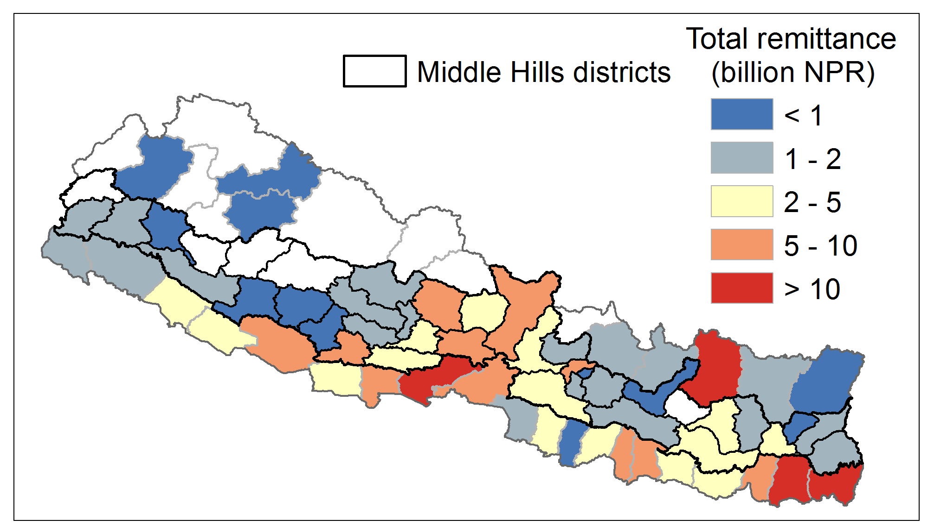
Current figures indicate that there are about four million migrants across Nepal, which represents at least one-third of the working male population. The impact of labor migration on Nepal’s socioeconomic landscape is substantial as remittance payments to rural households from family members who have gone to Kathmandu or abroad to work constitute a quarter of the income of all households (CBS, 2012). The 2001 and 2011 national population censuses contain questions on the absentee population and their demographic profile, the socio-economic profile of migrant households, migration patterns and immigration numbers, and also destination of migration, reasons for migration and transfer of remittances (Sharma & Sharma, 2011). In addition, the Migration Survey of Nepal (NIDS and World Bank, 2009) and the Nepal Labor Force Survey (CBS, 2008) examine remittance flow from foreign countries and to different regions of Nepal. Two Nepal Living Standard Surveys (I in 1995-96 and II in 2010-11) reveal contribution of remittances to household economy (CBS 1996, 2011). With the assistances of Drs. Sharma and Chhetri, we will acquire these data from CBS to map the distribution of remittance income at district and VDC scales (CBS 1996, 2011). Figure 3 shows distribution of total remittances by district in 2008 (NIDS and World Bank, 2009). To determine if there are statistically significant relationships between forest cover change and migration and remittances, we will compare Landsat-derived forest cover change data (Obj. 1) to the spatial distribution of remittance income from migrants working abroad (NIDS and World Bank, 2009).
Figure 3. Total remittances in 2008 by district in billions of Nepali Rupees (NPR) (NMS 2009).

We will then examine these relationships in greater detail in the 10 VDCs selected on the basis of their forest regrowth or stagnation between 1990 and the present. With the assistance of RHF students we will conduct qualitative research with farmers, CFUG officials, and government officials from village to national administrative levels to examine processes through which remittances and community forest management have affected observed changes in forest cover. Figure 4 shows the methodological workflow.

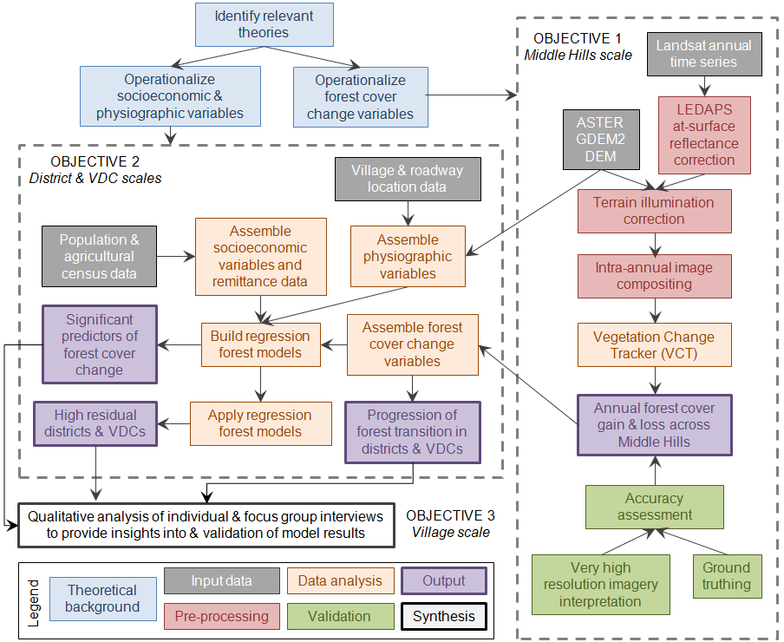

Figure 4. Methodological work flow.

- Management Plan and Project Timetable
The team assembled for this project consists of two institutions and a number of individuals with proven strong records in applied research and management in remote sensing and geographical data analysis, statistical analysis and modeling, coupled natural and human systems, and participatory decision making.
The East-West Center (EWC), established in 1960 by the U.S. Congress, promotes better relations and understanding among the people and nations of the United States, Asia, and the Pacific through cooperative study, research, and dialogue. The EWC is an independent, public, nonprofit organization with funding from the U.S. government, and additional support provided by private agencies, individuals, foundations, corporations, and governments in the region. The EWC will manage the project and support the collection and distribution of spatial data.
The Resources Himalaya Foundation (RHF) is a non-governmental, non-profit organization that was one of the eight recipients of the 2007 MacArthur Award for Creative and Effective Institutions (see http://www.resourceshimalaya.org/rhf/). RHF focuses on three areas – innovative research and policy analysis, mentoring and capacity building of younger generations, and creating a platform for knowledge management and dissemination. RHF programs with cross-cutting themes use quantitative biology and social science tools to triangulate livelihood and related issues connected with biodiversity conservation and climate change.
Our research team consists of scholars with extensive experience in LCLUC studies in mountainous regions, including Nepal, and with access to national and sub-national networks of decision-makers, academics, and activists. PI J. Fox (EWC) will oversee the project and coordinate the work with co-investigators in Nepal. Fox has studied and mapped forest cover change in the region since 1983. S. Saksena (EWC) will assist Dr. Fox in overseeing the project and will provide support on statistical analysis and modeling. K. Hurni (EWC) lived in Laos for four years and recently joined EWC. His previous work focused on mapping forest dynamics in the mountainous terrain of Mainland Southeast Asia. J. Van Den Hoek (EWC) has mapped patterns of forest cover change in the mountains of Southwest China and collected extensive interview data on village-level forest resource use and drivers of change. Drs. Pitamber Sharma and Ram Chhetri (RHF) have studied population change and adaptation in the mountains of Nepal for over 30 years. Dr. Sharma is the former vice chairman of the National Planning Commission. Dr. Chhetri teaches at Tribhuvan University and has worked extensively with community-based forest management in the Middle Hills. The project PI and Co-PIs will supervise all aspects of the project and coordinate their activities through monthly telecom meetings led by the PI. Table 2 shows the timetable of the research activities of different groups.
Regional-scale analysis: Hurni (EWC) and Van Den Hoek (EWC) will map forest cover change across the Middle Hills between 1990 and the present. In collaboration with Sharma and Chhetri (RH), Fox (EWC) will lead the collection of national population and agricultural census data. S. Saksena (EWC) will lead the analysis of the census data and, in collaboration with Van Den Hoek, will build and run the regression forest model to identify key socioeconomic and physiographic variables influencing forest cover change. All team members will collaborate to produce regional-scale maps highlighting areas of change in forest cover and help to analyze the physiographic and socioeconomic factors associated with these changes.
Local-scale analysis: All team members will collaborate to collect ground truth data for validating disturbance and regrowth across the Middle Hills. Sites of VCT-identified change are expected to be rarer than sites of stable forest or non-forest cover, so they will be oversampled proportionate to their abundance. All team members will collaborate to identify a sample of VDC (at least 10) that have been mapped as showing regrowth or stagnation through this period for detailed study. Fox, Sharma, and Chhetri will then supervise RHF students to conduct focus group and household interviews at these study sites to develop a better understanding of how forest cover has changed and the factors driving those changes. Fox, Sharma, and Chhetri will also conduct interviews with farmers, CFUG officials, and government officials from a sample of sites to examine processes through which migration and remittance have affected observed changes in forest cover.
Integrated analysis: All team members will work together to produce databases, maps, peer review publications, and other products that show an integrated understanding of LCLUC in the Middle Hills at regional and local scales. We will focus on identifying where change is occurring, and the physiographic and socioeconomic variables most strongly associated with those changes.

Results from Prior NSF Support
Fox was P.I. on NSF Award No 0909410; 2009-2013, $1,398,380, ‘Coupled Natural-Human Systems and Emerging Infectious Diseases (EID): Anthropogenic environmental change and avian influenza in Vietnam.’ The project brought together a diverse multidisciplinary team of specialists from the East-West Center, University of Hawaii at Manoa, and Hanoi University of Agriculture in an effort to inform the EID research community about the significance of environmental change in disease outbreaks using digital commune-level data from Vietnam national censuses (1989, 1999, and 2009) and agricultural censuses (2001, 2006, and 2011) that captured both the changing nature of the built environment, and the loss of and diversification of agriculture systems; the database also includes a normalized difference vegetation index from 2006 Landsat images. The project produced 10 papers to date with more forthcoming, and 2 PhDs. Fox was also P.I. on NSF Award No BCS-0434043; 2004-2008; $550,000; ‘Understanding Dynamic Resource Management Systems and Land-Cover Transitions in Montane Mainland Southeast Asia.’ The project involved a multidisciplinary team to collect economic, demographic, institutional and cultural data to explain how land-use practices are impacted by events such as changes in national taxation policies or changes in roads and markets. The project became the foundation for a long-term longitudinal study of forest cover change in Northeast Thailand, Northern Laos, and Southern China. The project produced 17 papers and reports.

8. Intellectual Merit and Broader Impacts

8.1 Intellectual merit

Rudel et al. (2005) distinguished two forest transition pathways: economic development and forest scarcity, and suggests that the economic development pathway may be more prevalent in richer and less densely populated countries, whereas the forest scarcity pathway may be more prominent in densely populated and poorer countries. Hecht (2010) argues that none of the prevailing deforestation or forest transition models examine the effect of globalization on forest cover, particularly the globalization of labor and the role of remittance income on human dominated landscapes. This project examines these issues within the context of the Middle Hills of Nepal in a way that not only produces insights into the socioecological transformations of the region but also broadly advances our understanding of forest transition theory, community based natural resource management and globalization of labor and how these literatures speak to each other. The project will further our understanding of the roles of spatial information technology for understanding long-term processes of socioecological change in mountain environments. The research will provide expertise on a complex and little understood set of relationships between policy-making, economic development, and changes in forest cover. Because similar processes are occurring elsewhere in South Asia and worldwide, insights into these processes will have broad applicability. The project’s significance to the NSF GSS program lies in its improved methods for mapping forest cover in mountainous regions, its integration of methods and datasets for conducting a comprehensive, interdisciplinary assessment of forest cover change, and its engagement with theory.

8.2 Broadening the participation of underrepresented groups
The collaboration among the two participating institutions in this project will provide unique opportunities for students to interact with experts in Geography, Spatial Sciences, and geospatial technologies and to develop crucial skills for studying human-environment interactions and the transformation of forest landscapes. The East-West Center funds students from the Asia-Pacific region (including the U.S.) to obtain graduate degrees at the University of Hawaii. Recruitment of student participants from among underrepresented groups including women, native Hawaiians, and South Asian immigrants to the U.S. will be a high priority. The Resources Himalaya Foundation seeks to mentor young graduates in environmental and social sciences on the path to becoming dedicated conservationists. Significant funding resources and time commitments will be devoted to improving teaching and learning and broadening participation of underrepresented groups at the University of Hawaii, Tribhuwan University in Nepal, and the Resources Himalaya Foundation. Recruitment of student participants from among underrepresented groups including women, native Hawaiians, and South Asian immigrants to the U.S. will be a high priority. We seek to meet the urgent need to look at the social implications of forest cover change for marginalized groups who are sorely underrepresented in discussions on the human dimensions of global environmental change.

8.3 Dissemination of project results
We will disseminate project results broadly through scientific publications and presentations, and data and model sharing in national data centers, and focus on delivering scientific results in forms useful for decision- makers and the public through stakeholder engagement. The scientific results of the study
will have direct societal benefits through: 1) significantly enhanced understanding of the effects of forest cover dynamics; 2) increased the awareness of environmental impacts of foreign remittances and 3) identification of adaptation needs and response strategies for coping with the effects of changes in forest cover. The project has already established a web site where the proposal, background readings,
and related materials and links can be found at: http://www.eastwestcenter.org/node/34717. Reports will be prepared in English, and Nepali languages. Dissemination of research results will be facilitated by the experience and established infrastructure of the East-West Center with long-established links in Asia. Research findings will be presented both at local seminars in the region involving the scientific and development community as well as at international fora.

Table 2: Schedule of proposed research activities.
Regional Scale Analysis |  | Y1 | Y2 | Y3
Acquire 30 m ASTER Global Digital Elevation Model (GDEM2) topographic elevation data

Build comprehensive database of satellite imagery for the Middle Hills
Generate annual Landsat composites and apply LEDAPS at-surface reflectance correction
Input cloud-free composites and GDEM2 to Tan et al. (2013) illumination correction model
Input terrain illumination-corrected imagery to Vegetation Change Tracker (VCT)
Map annual disturbances, long-term disturbance trends, and regeneration 1990-present
Collect ground truth data and examine VHR imagery to assess accuracy of forest change maps
Conduct literature review and socioeconomic factors hypothesized to be associated with successful community forestry
Acquire and examine physiographic, demographic, and socioeconomic databases
Combine the forest cover change maps with physiographic and socioeconomic data
Build and run regression forest model to identify key socioeconomic and physiographic variables influencing forest cover change.
Examine locations where modeled forest cover change deviates from that observed
Write papers
Publication, conference presentations
Local Scale Analysis
Identify sample of successful and unsuccessful community forests for field study
Examine locations where modeled forest cover change exhibits high model residuals in a sample of VDCs
Conduct focus group discussions and household interviews in VDCs across the spectrum of remittance income

Produce integrated understanding of forest cover change in these VDCs
 | Write papers
Publication, conference presentations
Integrated Analysis
Produce databases, maps, peer review publications, and other products that show an integrated understanding of forest cover change in the region at regional and local scales.

